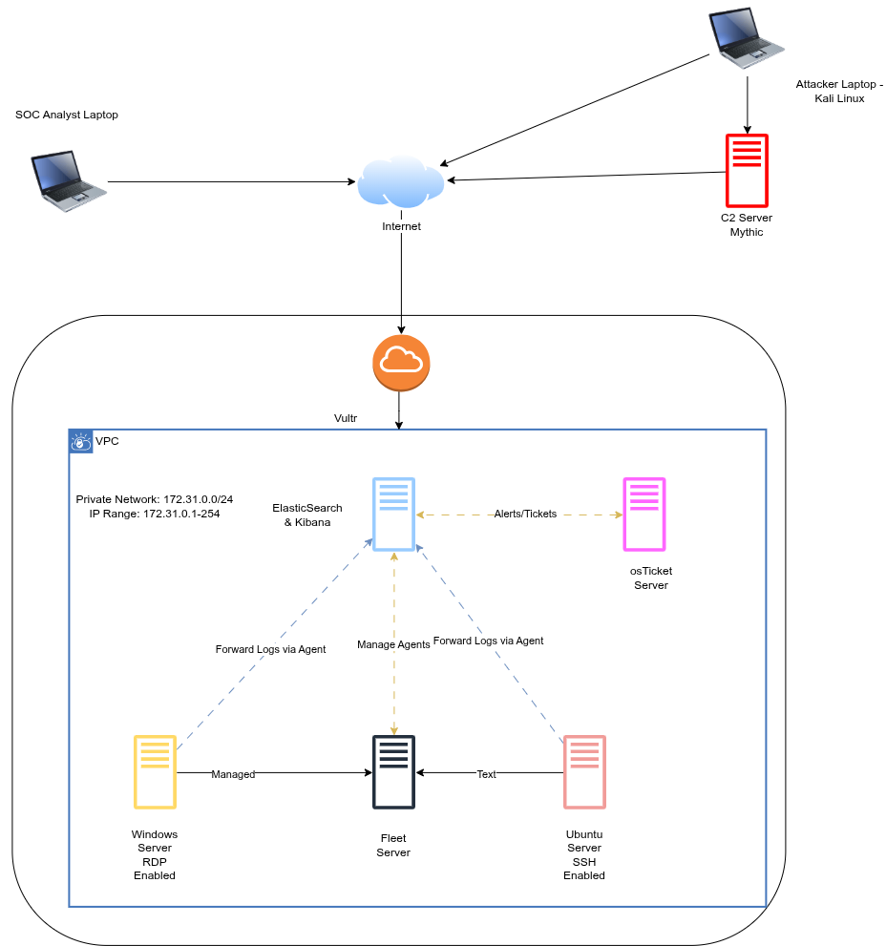
Image 1: Overview Topology
In this lab, I will set up around 6-8 virtual machines using Vultr - a cloud service provider. The virtual machines will include:
- A Linux server running elasticsearch & kibana for log management and visualization.
- A Fleet server for centrally managing Elastic Agents across the environment.
- A Windows server running osTicket for ticket management.
- A linux server running an ssh service.
- A Windows server with RDP enabled.
- Another linux server will act as the attacker’s C2 server, with Mythic framework installed.
The communication flow between these components are illustrated in Figure 1.
I will simulate brute-force attacks against both the RDP and SSH service. Finally, I will execute a malware payload on one of the target machines and simulate its communication with the Mythic C2 server.
Afterward, I will investigate detected activities using ELK SIEM and perform incident response actions via Elastic Defend.

CHAPTER 1: ELK STACK OVERVIEW
1.1. Logical Concepts
- Documents: are the basic unit of information that can be indexed in Elasticsearch expressed in JSON, which is the global internet data interchange format. To easier understand, we can think of a document like a row in a relational database, representing a given entity, the thing you’re searching for.
- Indices: An index is a collection of documents that have similar characteristics. An index is the highest level entity that we can query against in Elasticsearch. We can think of the index as being similar to a table in a relational database schema. Any documents in an index are typically logically related.
- An Elasticsearch index isn't a single physical file or table sitting on one hard drive. It is a virtual abstraction that routes your data across a distributed system.
- When you create an index, Elasticsearch divides it into Shards.
- Primary Shards: Your index is split into pieces (primary shards). If your products index has 3 primary shards, roughly one-third of your products live in Shard 1, one-third in Shard 2, and one-third in Shard 3. This allows Elasticsearch to distribute the data across multiple servers (nodes) so searches can happen in parallel.
- Replica Shards: These are exact copies of your primary shards. They serve two purposes: high availability (if the node holding Primary Shard 1 crashes, Replica Shard 1 takes over) and search throughput (read requests can be handled by replicas)..
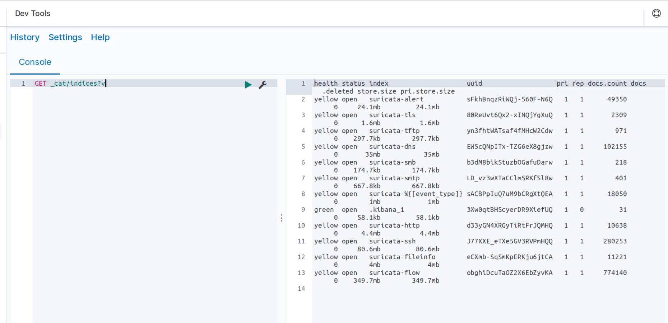
Figure 2: example indices from Kibana dashboard
- Inverted Indices: When performing full-text searches, we are actually querying an inverted index and not the JSON documents that we defined when indexing the documents. An inverted index consists of all of the unique terms that appear in any document covered by the index. For each term, the list of documents in which the term appears, is stored.
Once the text is analyzed into individual tokens (words), Lucene sorts every unique token alphabetically. This sorted list is the Term Dictionary.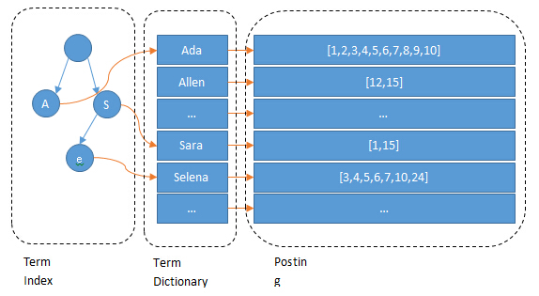
Figure 3: Lucene Inverted Index Architecture. Source: Hongyang
Read more in [2].
Next to every word in the Term Dictionary is a pointer to a Postings List. This is an integer array containing the IDs of every single document where that word appears.
But it stores much more than just the Document ID:
- Term Frequency (TF): How many times the word appears in the document (used to calculate relevance scoring, like BM25).
- Positions: Exactly where the word appears in the document (e.g., word #4 and word #12). This is what makes "Phrase Matching" (searching for exact sentences) and "Proximity Searches" possible.
- Offsets: The exact character start and end positions, which is what powers the highlighting feature in Kibana.
Because Postings Lists are just arrays of sorted integers, Lucene uses advanced compression techniques (like Frame of Reference / Delta Encoding) to keep them incredibly small in memory. If a word appears in Document IDs [100, 105, 108], Lucene actually stores the gaps: [100, 5, 3].

1.2. Definition
- ElasticSearch: At its core, you can think of Elasticsearch as a server that can process JSON requests and give you back JSON data.Elasticsearch is a distributed, open-source search and analytics engine built on Apache Lucene and developed in Java. It started as a scalable version of the Lucene open-source search framework then added the ability to horizontally scale Lucene indices. Elasticsearch allows you to store, search, and analyze huge volumes of data quickly and in near real-time and give back answers in milliseconds. It use ES|QL(Elastic Search Query Language). Reference more in [1]
- Logstash: Logstash is used to aggregate and process data and send it to Elasticsearch. It is an open-source, server-side data processing pipeline that ingests data from a multitude of sources simultaneously, transforms it, and then sends it to collect. Logstash is an ETL (Extract, Transform, Load) tool. It uses filters (like Grok) to take messy, raw text lines and parse them into structured JSON fields before sending them away. For example, logstash extracts an IP address from a syslog string, converts a string to an integer, or renames a field.
- Kibana: is a data visualization and management tool for Elasticsearch that provides real-time histograms, line graphs, pie charts, and maps. It lets you visualize your Elasticsearch data and navigate the Elastic Stack.
- Beats: Beats is a collection of lightweight, single-purpose data shipping agents used to send data from hundreds or thousands of machines and systems to Logstash or Elasticsearch. Beats are great for gathering data as they can sit on your servers, with your containers, or deploy as functions then centralize data in Elasticsearch.
- Type of beat:
- Filebeat (logs): It monitors specified log files, reads new log entries and forwards them to Elasticsearch or Logstash for further processing and analysis.
- Metricbeat: It can monitor metrics such as CPU usage, memory usage, disk space, network traffic, service statistics and send them to Elasticsearch.
- Packetbeat (network data): Packetbeat is used to monitor network traffic and collect information about network transactions
- Winlogbeat (windows events): Winlogbeat is designed to collect Windows Event Logs from Windows systems
- AuditBeat: Auditbeat collects security-related information from Linux systems.
- Heartbeat: Heartbeat is used to monitor the availability and status of services. It can periodically check whether websites, APIs, TCP services, and other endpoints are reachable and report their availability and response time.
Compare Beats vs Elastic Agent:

Item | Beats | Fleet-managed Elastic Agent | Standalone Elastic Agent | Description
Single agent for all use cases |  |  |  | Elastic Agent provides logs, metrics, and more. You’d need to install multiple Beats for these use cases.
Install integrations from web UI or API |  |  |  | Elastic Agent integrations are installed with a convenient web UI or API, but Beats modules are installed with a CLI. This installs Elasticsearch assets such as index templates and ingest pipelines, and Kibana assets such as dashboards.
Configure from web UI or API |  |  | (optional) | Fleet-managed Elastic Agent integrations can be configured in the web UI or API. Standalone Elastic Agent can use the web UI, API, or YAML. Beats can only be configured through YAML files.
Central, remote agent policy management |  |  |  | Elastic Agent policies can be centrally managed through Fleet. You have to manage Beats configuration yourself or with a third-party solution.
Central, remote agent binary upgrades |  |  |  | Elastic Agents can be remotely upgraded through Fleet. You have to upgrade Beats yourself or with a third-party solution.
Add Kibana and Elasticsearch assets for a single integration or module |  |  |  | Elastic Agent integrations allow you to add Kibana and Elasticsearch assets for a single integration at a time. Beats installs hundreds of assets for all modules at once.
Auto-generated Elasticsearch API keys |  |  |  | Fleet can automatically generate API keys with limited permissions for each Elastic Agent, which can be individually revoked. Standalone Elastic Agent and Beats require you to create and manage credentials, and users often share them across hosts.
Auto-generate minimal Elasticsearch permissions |  |  |  | Fleet can automatically give Elastic Agents minimal output permissions based on the inputs running. With standalone Elastic Agent and Beats, users often give overly broad permissions because it’s more convenient.
Data streams support |  |  |  | Both Beats (default as of version 8.0) and Elastic Agents use data streams with easier index life cycle management and the data stream naming scheme.
Variables and input conditions |  | (limited) |  | Elastic Agent offers variables and input conditions to dynamically adjust based on the local host environment. Users can configure these directly in YAML for standalone Elastic Agent or using the Fleet API for Fleet-managed Elastic Agent. The Integrations app allows users to enter variables, and we are considering a UI to edit conditions. Beats only offers static configuration.
Allow non-superusers to manage assets and agents |  |  | (optional) | Starting with version 8.1.0, a superuser role is no longer required to use the Fleet and Integrations apps and corresponding APIs. These apps are optional for standalone Elastic Agent. Beats offers finer grained roles.
Air-gapped network support |  | (limited) |  | The Integrations and Fleet apps can be deployed in an air-gapped environment self-managed deployment of the Elastic Package Registry. Fleet-managed Elastic Agents require a connection to our artifact repository for agent binary upgrades. However the policy can be modified to have agents point to a local server in order to fetch the agent binary.
Run without root on host |  |  |  | Fleet-managed Elastic Agents, Standalone Elastic Agents, and Beats require root permission only if they’re configured to capture data that requires that level of permission.
Multiple outputs |  |  |  | The policy for a single Fleet-managed Elastic Agent can specify multiple outputs.
Separate monitoring cluster |  |  |  | Fleet-managed Elastic Agents, Standalone Elastic Agent and Beats can send to a remote monitoring cluster.
Secret management |  |  |  | Elastic Agent stores credentials in the agent policy. Beats allows users to access credentials in a local keystore.
Progressive or canary deployments |  | Stack9.1+ |  | To upgrade Fleet-managed Elastic Agents progressively, you can configure an automatic upgrade in the Elastic Agent policy. Stack9.1+  With standalone Elastic Agent and Beats you can deploy configuration files progressively using third party solutions.
Multiple configurations per host |  | (uses input conditions instead) | (uses input conditions instead) | Elastic Agent uses a single Elastic Agent policy for configuration, and uses variables and input conditions to adapt on a per-host basis. Beats supports multiple configuration files per host, enabling third party solutions to deploy files hierarchically or in multiple groups, and enabling finer-grained access control to those files.
Compatible with version control and infrastructure as code solutions |  | (only using API) |  | Agent policies created in the Fleet UI can't be managed with external version control or infrastructure as code solutions. However, you could develop a solution that uses the Fleet API or adds a preconfigured policy to Kibana. Beats and Elastic Agent in standalone mode use a YAML file that is compatible with these solutions.
Spooling data to local disk |  |  |  | This feature is currently being considered for development.

[3]
1.2. How it work
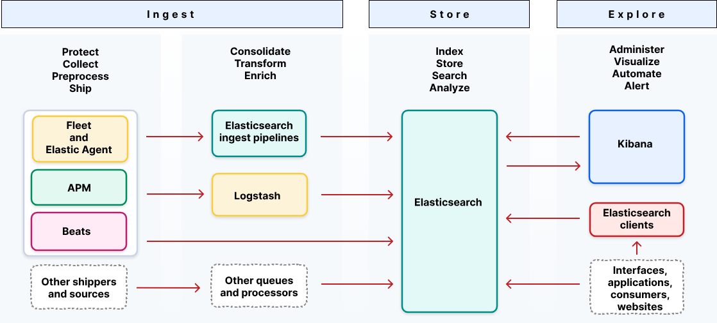
Figure 4: Elastic Stack Ingestion Architecture
1. Collection (The Edge)
Data originates on your servers, applications, or network devices. To get this data out, you deploy a shipper.
- Elastic Agent: The modern, unified agent managed centrally via Fleet.
- Beats: Older, purpose-built, lightweight shippers (e.g., Filebeat for logs, Metricbeat for CPU/RAM).
- Direct APIs: Applications can push JSON data directly via HTTP REST APIs, or through native language clients (Python, Node.js) and OpenTelemetry (OTel).
2. Buffering and Routing (Optional Middleware)
For massive scale, sending data directly to Elasticsearch can overwhelm the cluster during traffic spikes.
- Kafka or Redis: Acts as a massive shock absorber. Agents write to Kafka, and downstream consumers read from Kafka at a pace Elasticsearch can handle.
- Logstash: Often sits here as a central routing hub. It can read from Kafka, apply heavy transformations, and route specific data to different Elasticsearch clusters or even third-party systems (like AWS S3 for cold storage).
3. Transformation (Ingest Pipelines)
Before data is written to disk, it usually needs to be cleaned, parsed, or enriched. If you aren't using Logstash, this happens entirely inside Elasticsearch using Ingest Pipelines [4].
- An Ingest Pipeline is a series of "processors" running on Elasticsearch Ingest Nodes.
- Processors modify the incoming JSON sequentially. For example: a grok processor extracts an IP address from a raw log string, an enriched processor looks up that IP to add geolocation data (city/country), and a remove processor drops unnecessary fields to save disk space.
4. Storage and Indexing
Once the data is transformed, it hits the final storage layer.
- Data Streams: Time-series data (like logs or metrics) is routed to Data Streams, which automatically manage rolling over to new backing indices based on size or age.
- Analysis: As discussed previously, the text fields are passed through Analyzers to build the Term Dictionary and Postings Lists (the inverted index).
- Persistence: The data is written to immutable Lucene segments on disk, making it instantly available for Kibana dashboards to query.

REFERENCES:
[1]
[2]
[3] https://www.elastic.co/docs/reference/fleet/beats-agent-comparison

DAY 03: Elasticsearch Set up

DAY 4: KIBANA SETUP
DAY 5: INSTALL WINDOWS SERVER
DAY 6: ELASTIC AGENT AND FLEET SERVER INTRODUCTION

Day 07: Elastic Agent and Fleet Server Setup
Now, we would create a linux server machine to install Fleet Server for managing Agents on it. I also created a Windows Server machine to install Elastic Agent and expose RDP service as I mentioned in DAY 01. In this dashboard, 2 machines have just been created respectively MyDFIR-WIN-vinh and MyDFIR-FleetServer.
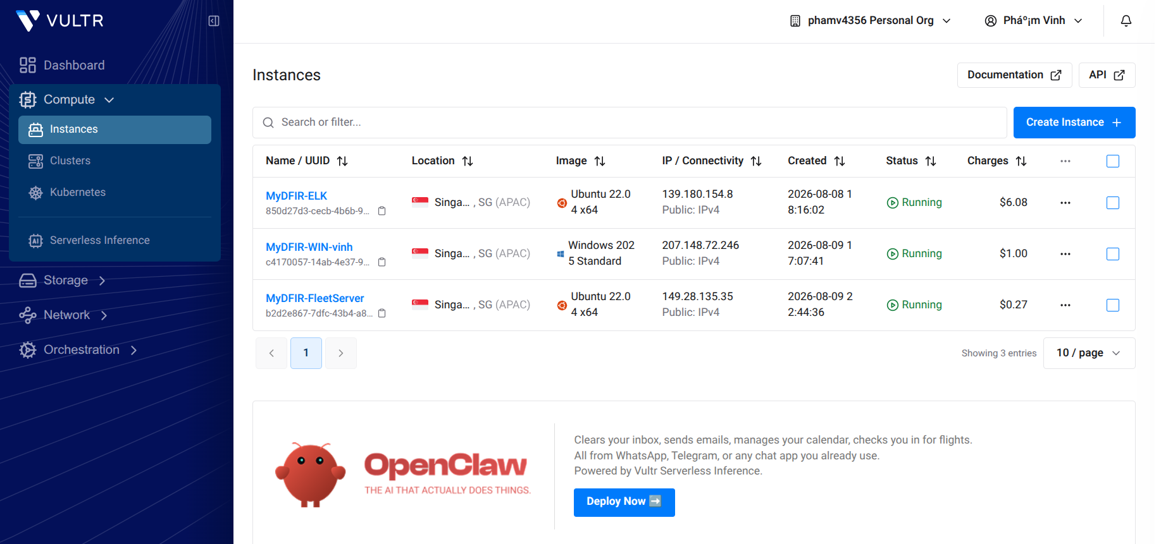
Figure 7.1: Added Fleet Server and Windows Server virtual machine
Next steps, I will configure each of these virtual machines.

Fleet Server Configuration:
First, I will add Fleet Server on Kibana GUI, Management > Fleet > Add Fleet Server.
Fill name of Fleet Server, URL type https://149.28.135.35:8220 > Click Generate Fleet Server Policy;
Scroll down at step 2, copy entire command lines in the “Linux Tar” tab and paste it to Linux Server, which wants to install Fleet Server on that. It will automatically enroll in the ELK Stack system.
⚠️ Note: You maybe need to add firewall policy allow connection Inbound to Fleet Server machine from cloud service provider (aws, GCP,.. In this case is Vultr), and also host-based firewall on that machine to enroll successfully. Fleet Server connects to ElasticSearch through port 9200 for writing data logs and metrics to the cluster.
Allow inbound port 9200 on Fleet Server: sudo ufw allow 9200
Now, back into our dashboard, it will notify that “Fleet Server connected”.



Next step, we continue to enroll Elastic Agents to Fleet Server for centralized management.
Click “Continue enrolling Elastic Agent” > Create Policy for Windows Server > Scroll down and copy entire command lines and paste to Powershell of Windows Server machine to install Elastic Agent and enroll automatically in Fleet Server. Remember to adjust UFW on the fleet server to allow incoming to port 8220, because that is a port service for communication between fleet server and elastic agents.
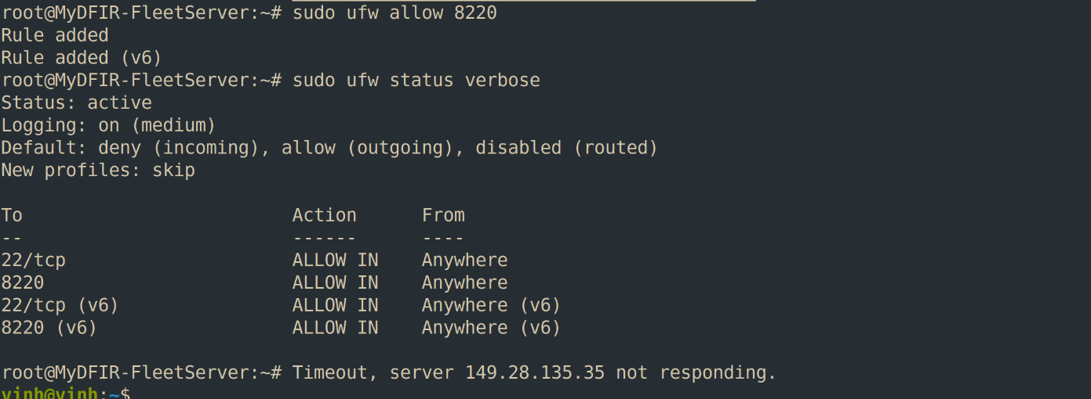
Windows Server, which need to be monitor, installed Agent successfully at the moment,
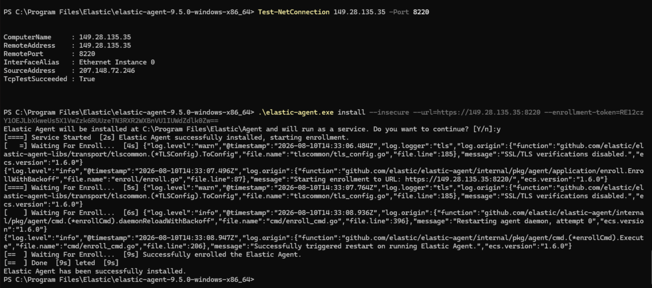

Day 08: Sysmon overview
- Sysmon Definition
Sysmon is a free Windows system service and device driver from Microsoft's Sysinternals Suite that logs deep activity data to the Windows Event Log. It provides detailed information about process creations, network connections, and changes to file creation time.
- Sysmon Capabilities:
Sysmon includes the following capabilities:
- Logs process creation with full command line for both current and parent processes.
- Records the hash of process image files using SHA1 (the default), MD5, SHA256 or IMPHASH.
- Multiple hashes can be used at the same time.
- Includes a process GUID in process create events to allow for correlation of events even when Windows reuses process IDs.
- Includes a session GUID (important field) in each event to allow correlation of events on same logon session.
- Logs loading of drivers or DLLs with their signatures and hashes.
- Logs open for raw read access of disks and volumes.
- Optionally logs network connections, including each connection’s source process, IP addresses, port numbers, hostnames and port names.
- Detects changes in file creation time to understand when a file was really created.
- Modification of file create timestamps is a technique commonly used by malware to cover its tracks.
- Automatically reload configuration if changed in the registry.
- Rule filtering to include or exclude certain events dynamically.
- Generates events from early in the boot process to capture activity made by even sophisticated kernel-mode malware.
- Events
Some common Event IDs Sysmon record:
- Event id 1 - process creation. The ProcessGUID field is a unique value for this process across a domain to make event correlation easier
- Event id 3 - network connection (disabled by default). Each connection is linked to a process through the ProcessId and ProcessGuid fields.
- Event id 6/7/8 - driver/image load & create remote thread: The driver loaded events provides information about a driver being loaded on the system/The image loaded event logs when a module is loaded in a specific process/The CreateRemoteThread event detects when a process creates a thread in another process. This technique is used by malware to inject code and hide in other processes. Relate to some evasion techniques such as process injection,... (by ATT&CK).
- Event id 10 - Process access: The process accessed event reports when a process opens another process, an operation that’s often followed by information queries or reading and writing the address space of the target process. This enables detection of hacking tools that read the memory contents of processes like Local Security Authority (Lsass.exe) in order to steal credentials for use in Pass-the-Hash attacks.
- Event id 22 - dnsevent (dns query): This event is generated when a process executes a DNS query, whether the result is successful or fails, cached or not.
related Attack: Domain Generated Algorithm

Day 09: setup sysmon
Link to install the tool: https://learn.microsoft.com/en-us/sysinternals/downloads/sysmon
I will install configuration file from olaf repo on GitHub, access the link below and scroll down to find “sysmonconfig.xml” > Download Sysmon Folder.
Link sample Sysmon configuration file: https://github.com/olafhartong/sysmon-modular/blob/master/sysmonconfig.xml
⚠️ You can custom this xml file for demand.
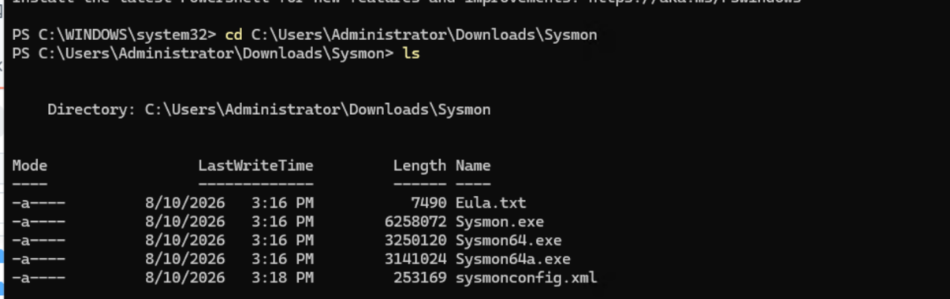
Figure 1: Folder contains Sysmon configuration and executable files
Install Sysmon as a service with a Sysmon64.exe file and specify the configuration file we just downloaded.
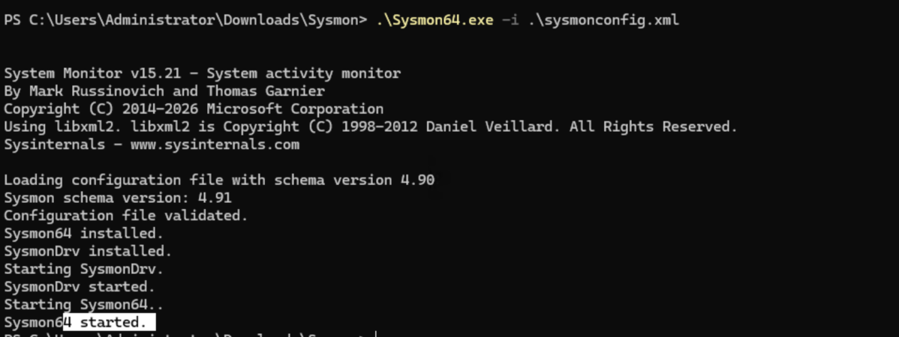
Figure 2: Installing Sysmon service
Now, we successfully installed Sysmon. You can verify by go to services.msc and scroll down to see Sysmon64 service running.


Figure 3: Sysmon service run successfully

DAY 10: ingest Sysmon & Windows defender logs to ElasticSearch
First, we want to add some Integrations for my Windows Policy:
- Sysmon Logs: Find Integration name Custom Windows Event Logs > Click Add Custom Windows Event Logs > Fill name “MyDFIR-WIN-Sysmon” > Channel name is Microsoft-Windows-Sysmon/Operational:

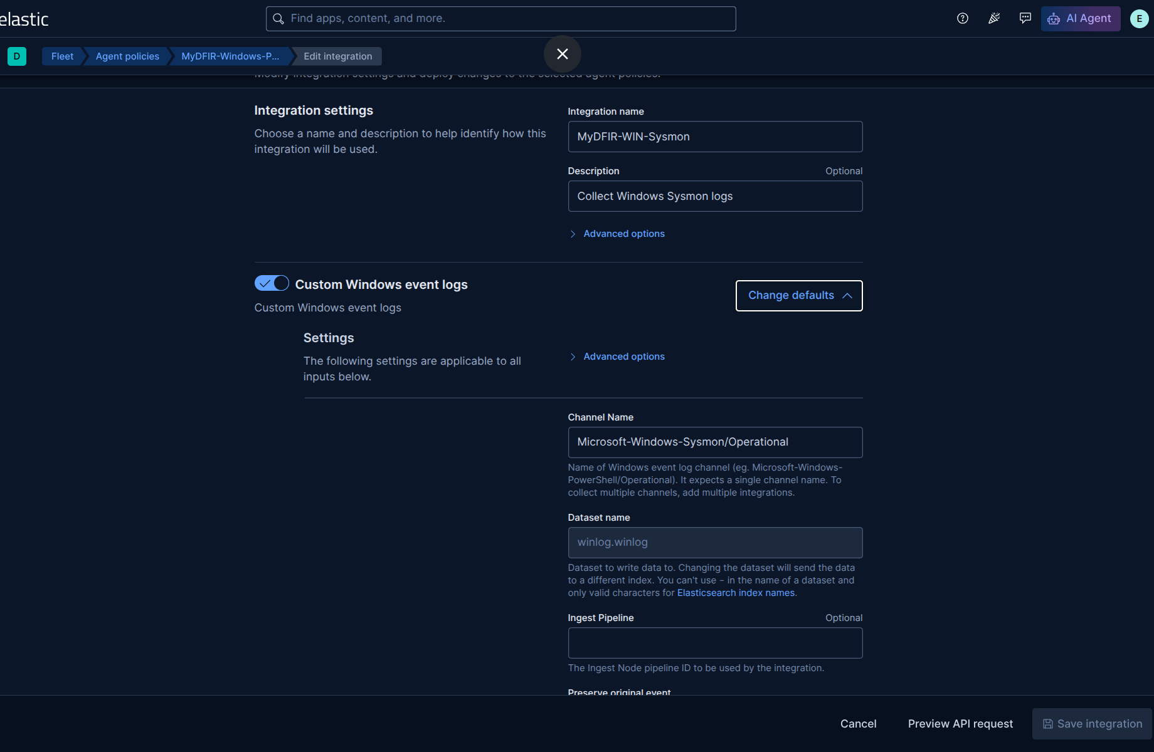
Figure 1: Add integration to collect Sysmon logs

Channel Name entries will be found on Windows Event Viewer (see in full name at Log properties window):
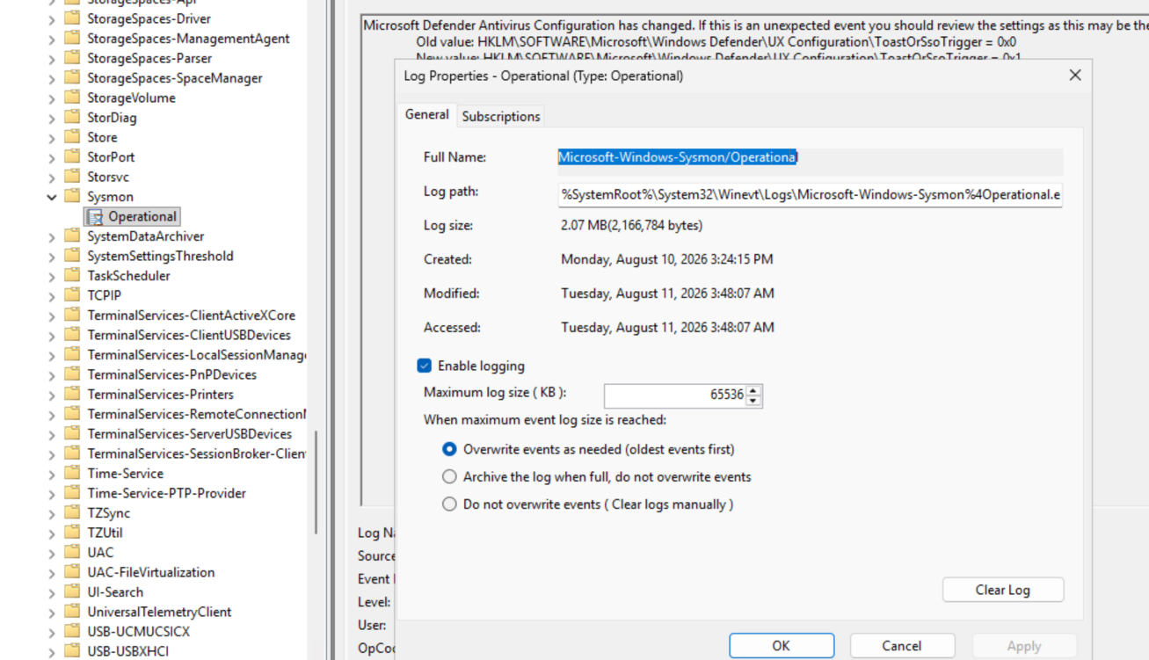
Figure 2: Location to find Log Channel Name on Windows
Scroll down and add this integration to MyDFIR-Windows-Policy policy > Save and deploy changes.

- Windows Defender Logs: The procedure is same as above
Refer to Event IDs: 1116, 1117 and 5001 for Windows Defender Logs at this link:
https://learn.microsoft.com/en-us/defender-endpoint/troubleshoot-microsoft-defender-antivirus

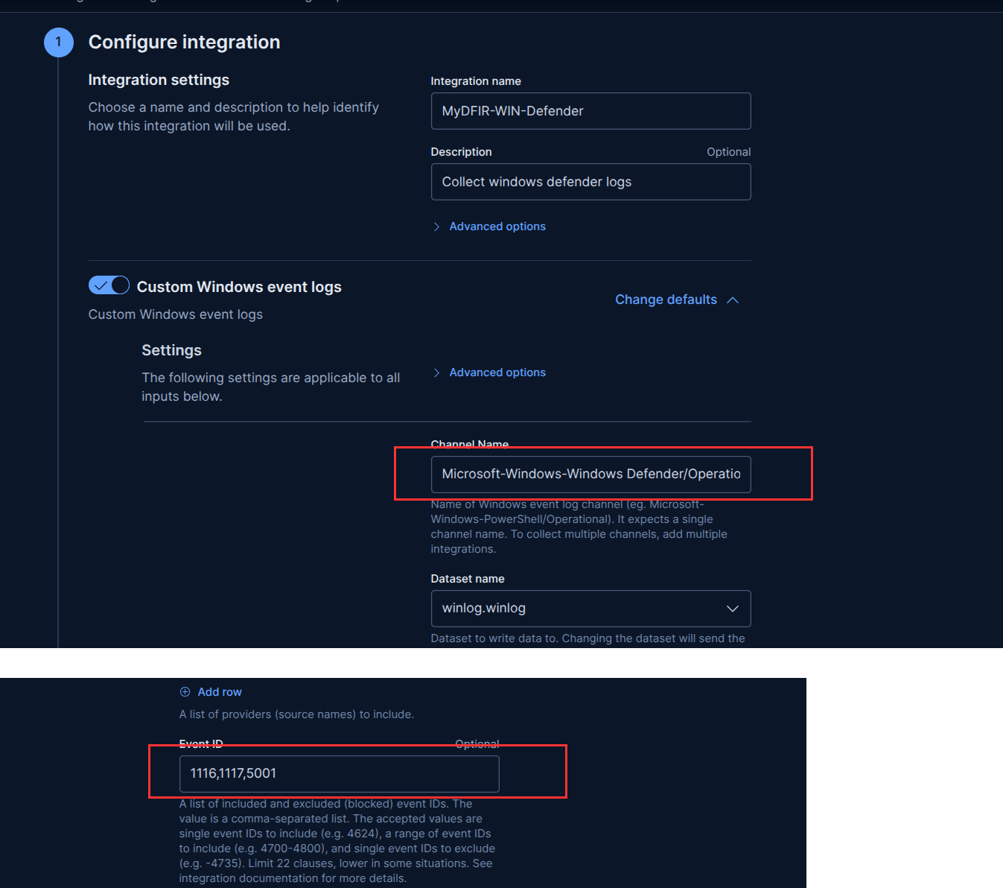
Figure 3: Set up Windows Defender Log Collection Integration
Save and deploy changes!

DAY 11: BRUTE-FORCE ATTACK
- Definition
Brute-force attack is trial-and-error methods where a hacker uses automated software to systematically guess passwords, login credentials, encryption keys until they find a correct combination.
- Type of Brute-force attack
- Dictionary attack: Use wordlists containing common passwords or credentials leaked from data breach.
- Credential stuffing: take advantage of reused credentials. Hackers use automated software or bots to inject stolen username and password pairs into website login forms to gain unauthorized access to user accounts.
- Protection methods:
- Password longer
- Using passphrase, refer to [5] for more details
- MFA (Multi-Factor Authentication)
- Tools: hydra, hashcat, john the ripper,...

DAY 12: Ubuntu ssh authentication log
Now, after we learn about what and how brute-force attacks work, next step, we will go to investigate real brute-force attack traffic from the internet to ssh service on my linux server machine.
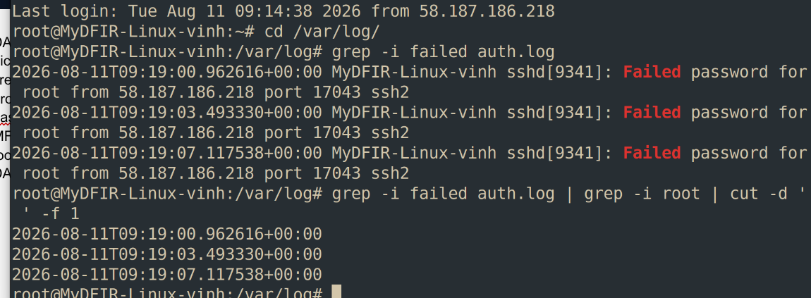
Figure 1: find failed login attempts in auth.log
As figure 1 shown above, I’m using grep utility to find failed login attempts. It shows 3 lines Failed password login for ssh service, these log lines were written Syslog standard.
The second command is used to filter the first column of log lines, which contains the timestamp of each event.
Next, I want to identify the source IPs initiating the connections to my Linux’s SSH service. By adjusting the column position - we specify whitespace as the delimiter in cut command, so column position we need is 9th field:

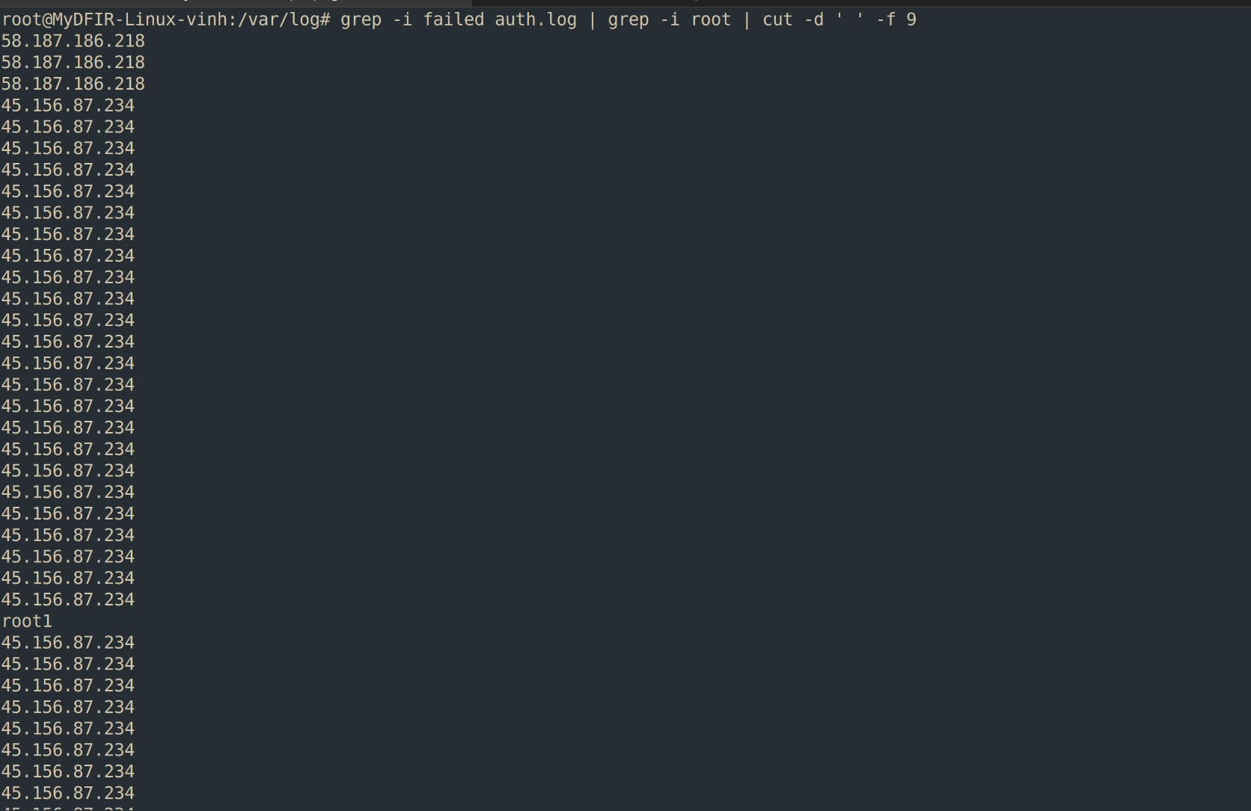
Figure 2: Filter source ip initiate connection
After filtering and analyzing frequency of source IPs, I will investigate related activities for suspicious ips using Kibana GUI.
Now, let’s go to the Discover tab and search: <suspicious ip address> <keyword for related activities>.
For example, as shown in Figure 3 below, I specify source ip 45.156.87.234 and activity keyword authentication failure. Elasticsearch uses an inverted index mechanism to look up matching documents efficiently. These are matching document returned by Elasticsearch and displayed in my dashboard:
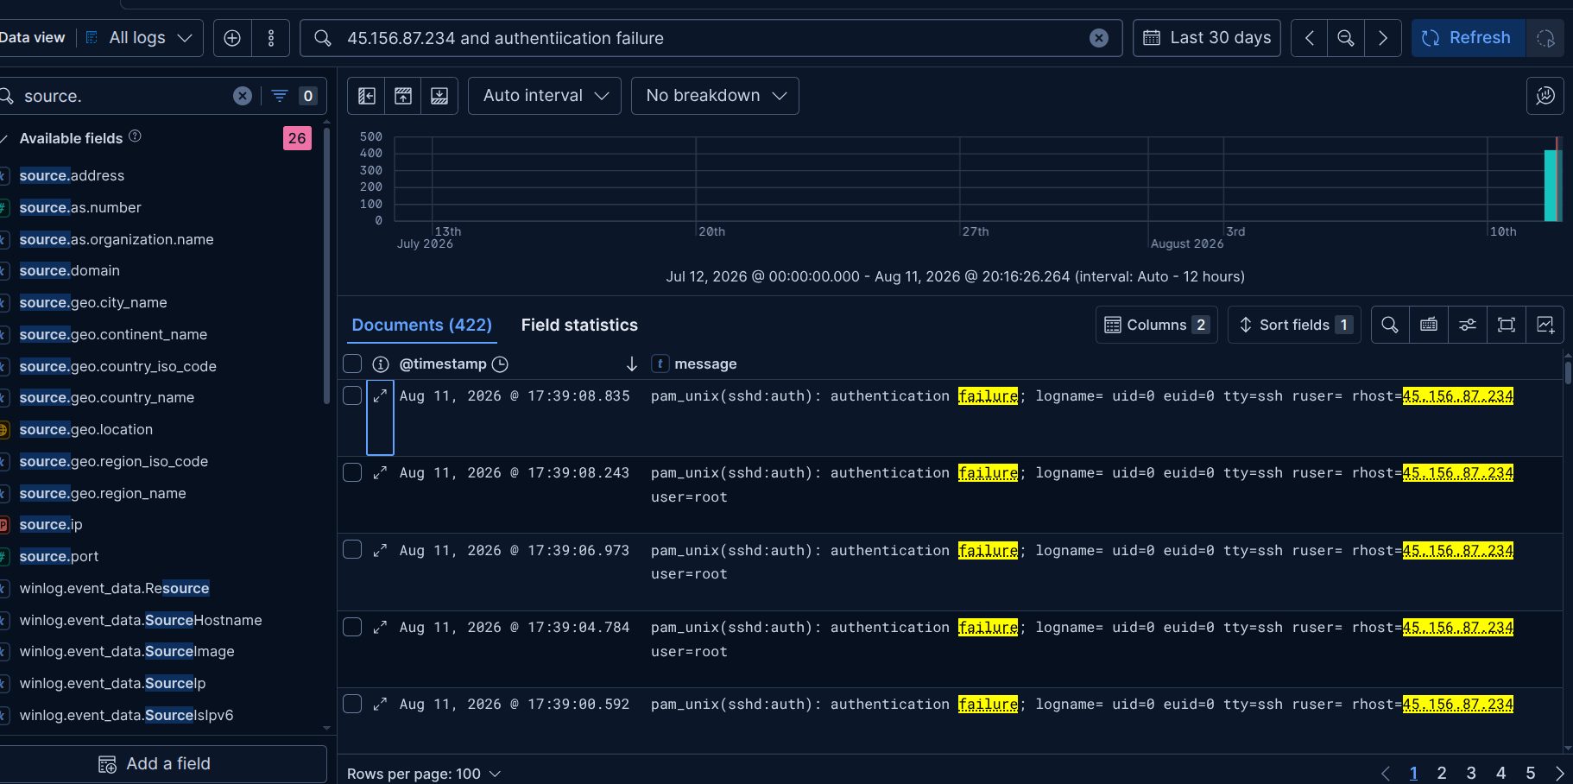
Figure 3: Search source ips on kibana discover
In the left-hand side of the GUI, there are a lot of available fields that provide us additional contextual information. We can hover through these fields and click the plus symbol to add columns to the table of documents below.

Day 14: Create Alerts and Dashboards in Kibana (part 1)
Following up from the previous post, today we will dive into creating Alerts and Dashboards in Kibana GUI.
First, I will filter by the agent name corresponding to my Linux’s hostname, MyDFIR-Linux-vinh. Then, I will look for SSH authentication failure events using the system.auth.ssh.event field. These events indicate failed login actions on my linux virtual machine, which is typical of brute-force attacks.
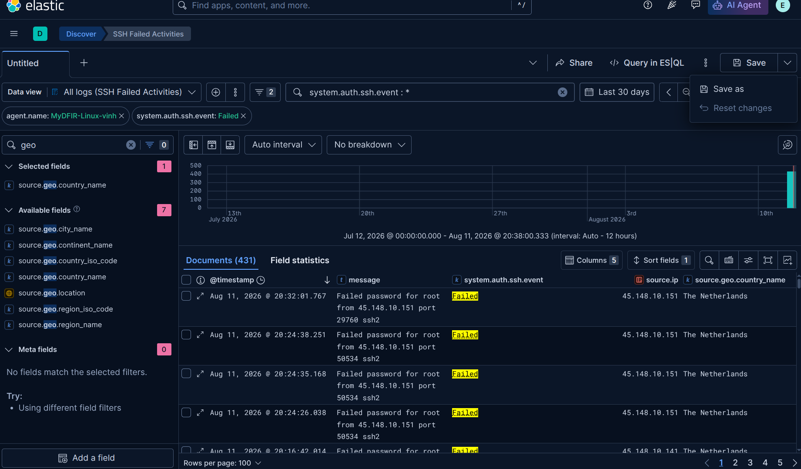
Figure 1: Search failed ssh events
Now, let’s move on to Maps to create dashboards that show the number of alerts by country. Access to Dashboards > Create dashboard > choose Maps > Choose “EMS boundaries” is World Countries and in Statistics Source entry, we choose Join field is source.geo.country_iso_code.

After that, we will use a query shown in Figure 2 to search Elasticsearch for documents related to SSH Authentication Failure and display the results on a map. This is a heatmap, which uses a range of colors across different regions to show different values or event densities in the dataset.
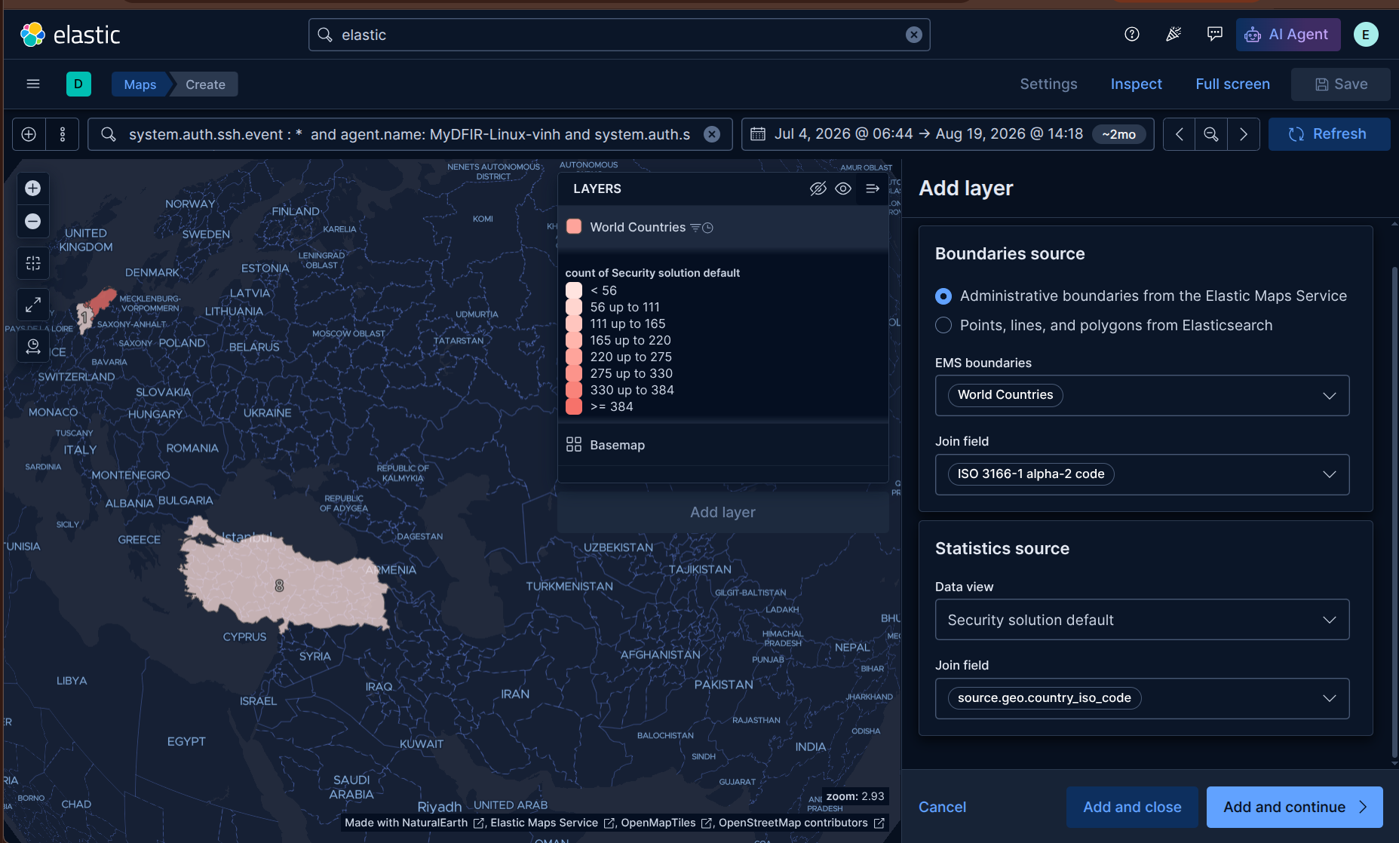
Figure 2:
As you can see in Figure 2, after we enter the query into the search bar and filter the time range to cover the specific time period when the attack happened, some countries are shaded with colors based on the number of matching events. The color intensity increases with the number of matching events. For example in Figure 2, when a region has more than 384 SSH Failed events, it will be displayed in the darkest shade of orange.
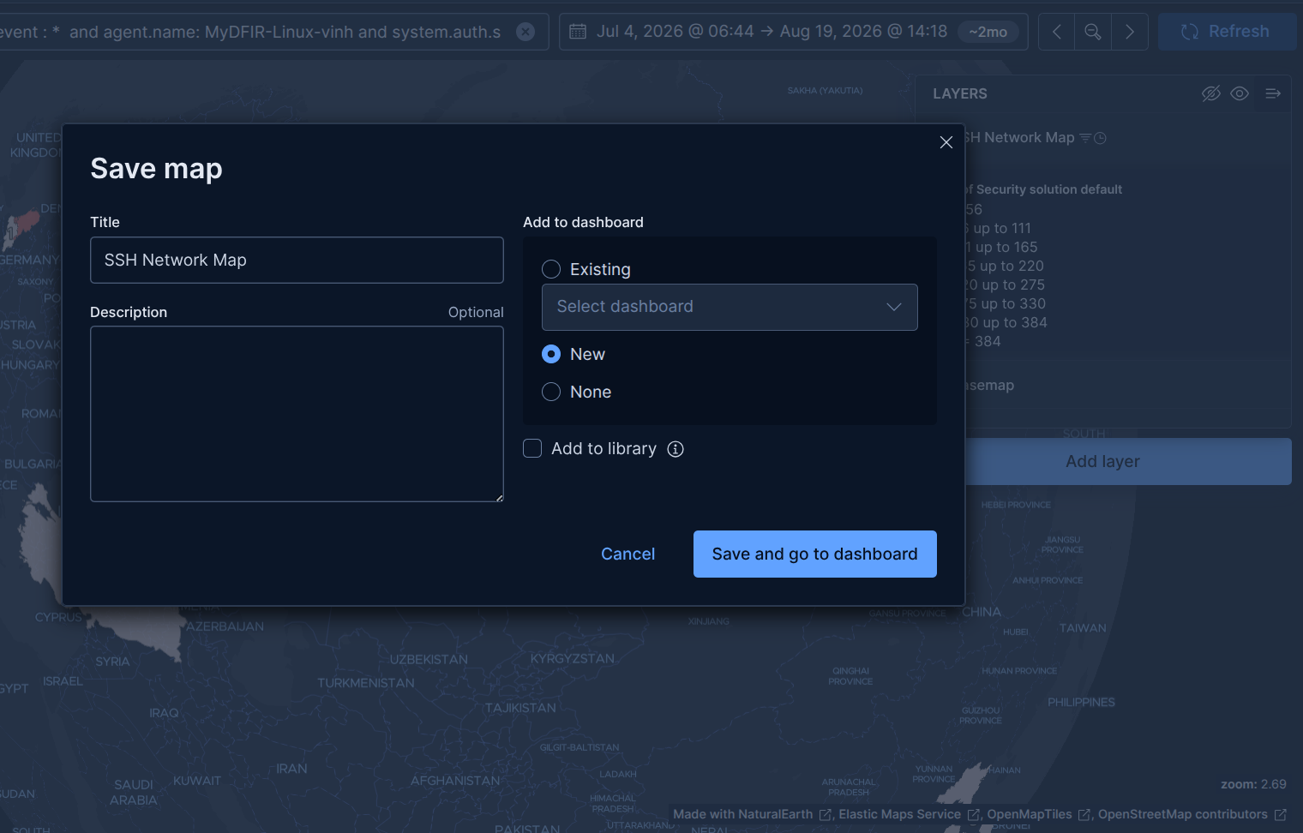
Figure 3: Save SSH Network Map
Finally, I want to add another Map widget to my dashboard, which displays successful SSH authentication. Now hover over the widget we just created, and click the three-dot icon and select Duplicate.
After duplicating the widget, change the name of the duplicated widget from “Failed” to “Successful”. Then, change the query from “Failed” to “Accepted”.
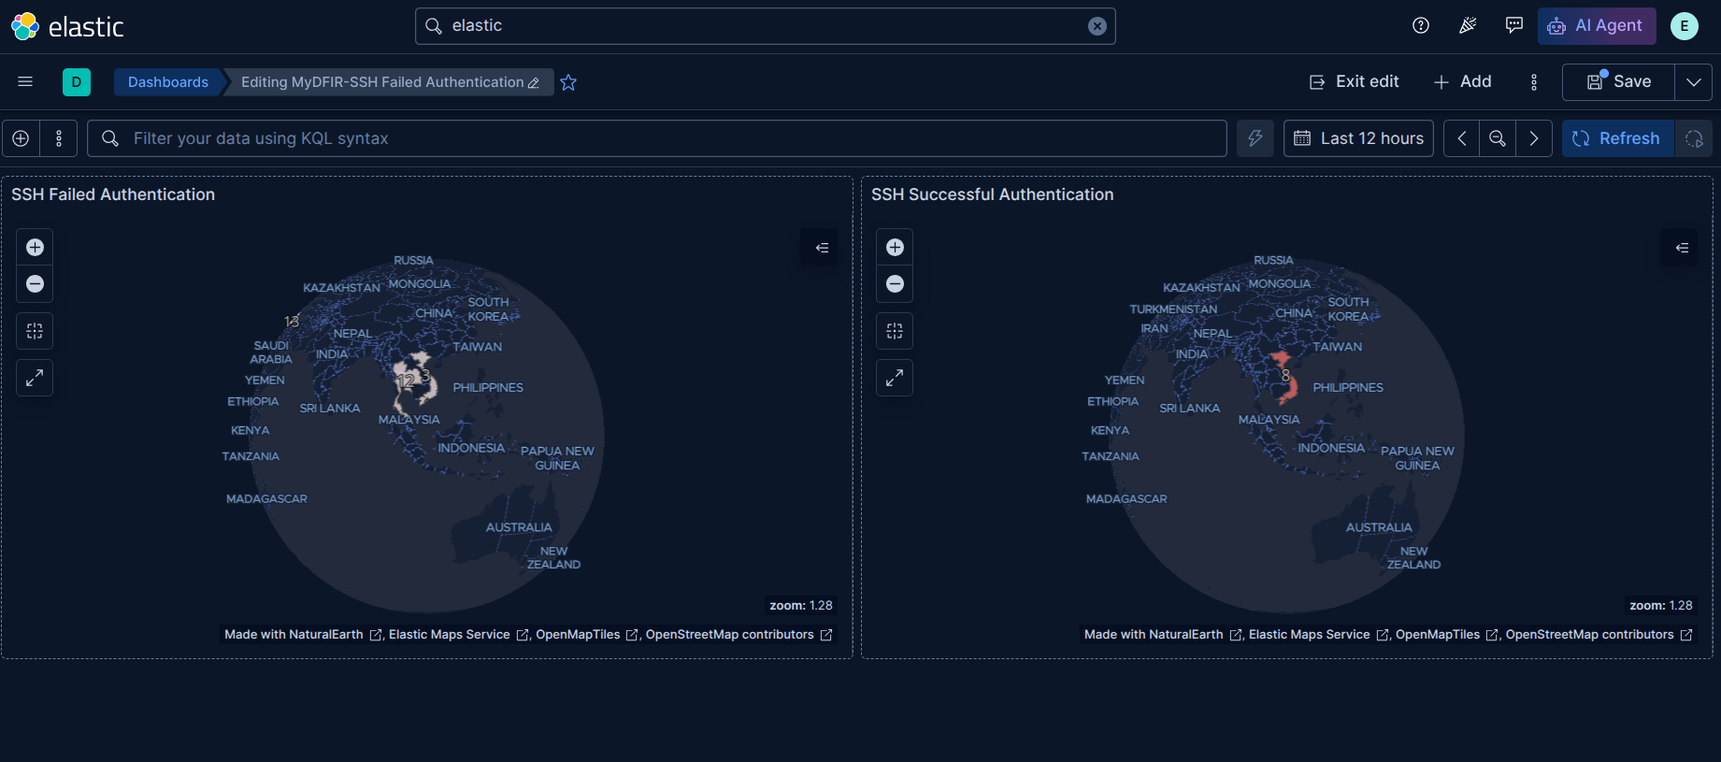
⚠️ Note: Remember to change the time range filter in order to view all events.

DAY 15: What is RDP?
RDP (Remote Desktop Protocol) is a secure network communication protocol built by Microsoft that lets you connect to and control a remote computer or server over a network as if you were sitting right in front of it.
There are some specialized search engines such as Shodan and Censys, that let us discover devices connected to the internet and identify the services they expose, such as servers, webcams, and routers, rather than just indexing traditional web pages.
Particularly, In these search engines, I will find which machines that expose RDP service on the internet, and the following platforms will provide us with more details about those devices:
- shodan.io:
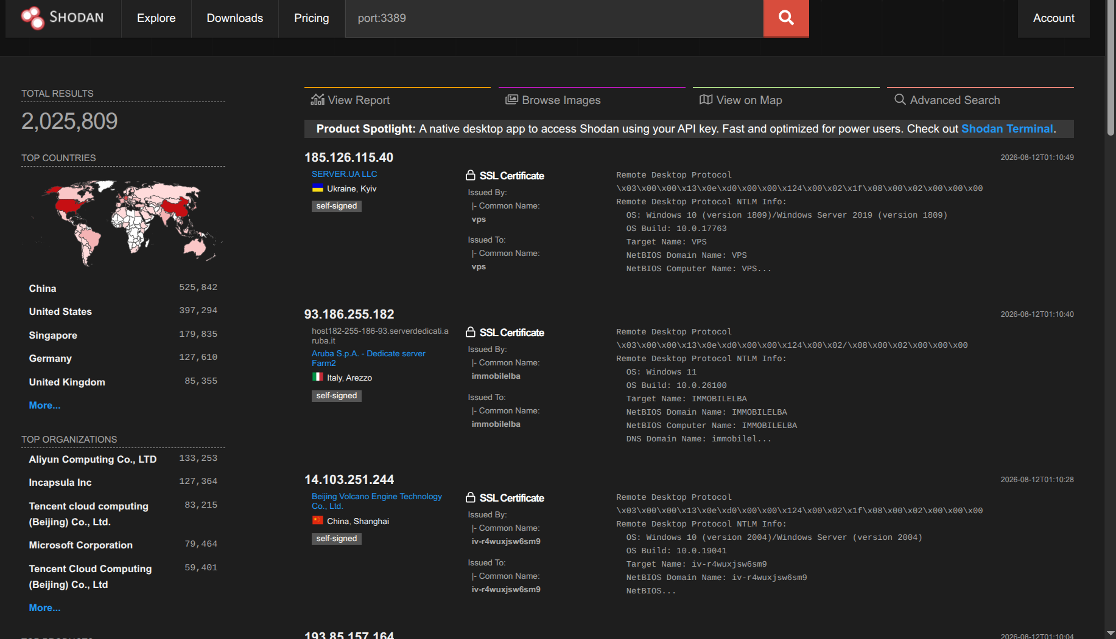
Figure 1: Results from shodan search engine
As you can see, I searched for port:3389, the default port for RDP protocol. There are more than 2 million results returned by this search engine. At the bottom, there is the TOP COUNTRIES category, which displays statistical results across multiple countries, such as China at the top, followed by the United States with 397,294 detected devices,...
The TOP ORGANIZATIONS category shows the number of results associated with different organizations or ISPs.
In the center of the interface, it displayed details of each detected device. These include SSL Certificate information, OS version, Target name, NetBIOS Domain Name,... Furthermore, right beneath the IP address, you can find the country and organization associated with the device.
- Censys - https://search.censys.io/:
Similar to Shodan, Censys is also a search engine for discovering attack surfaces by focusing on structured asset inventory and certificate tracking, while Shodan specializes in IoT discovery and banner-based reconnaissance.
I also searched for hosts on the Internet that expose RDP service on Cencys. The results are not divided into categories as Shodan. Instead, it organizes to fields, making it better to filter and display matched fields. As shown in Figure 2 below, Censys has a lot of Filter types like ASSET TYPES, SOFTWARE VENDORS, SOFTWARE PRODUCTS, CERTIFICATE LABELS,... These categories allow users to filter search results in more detail than with Shodan.
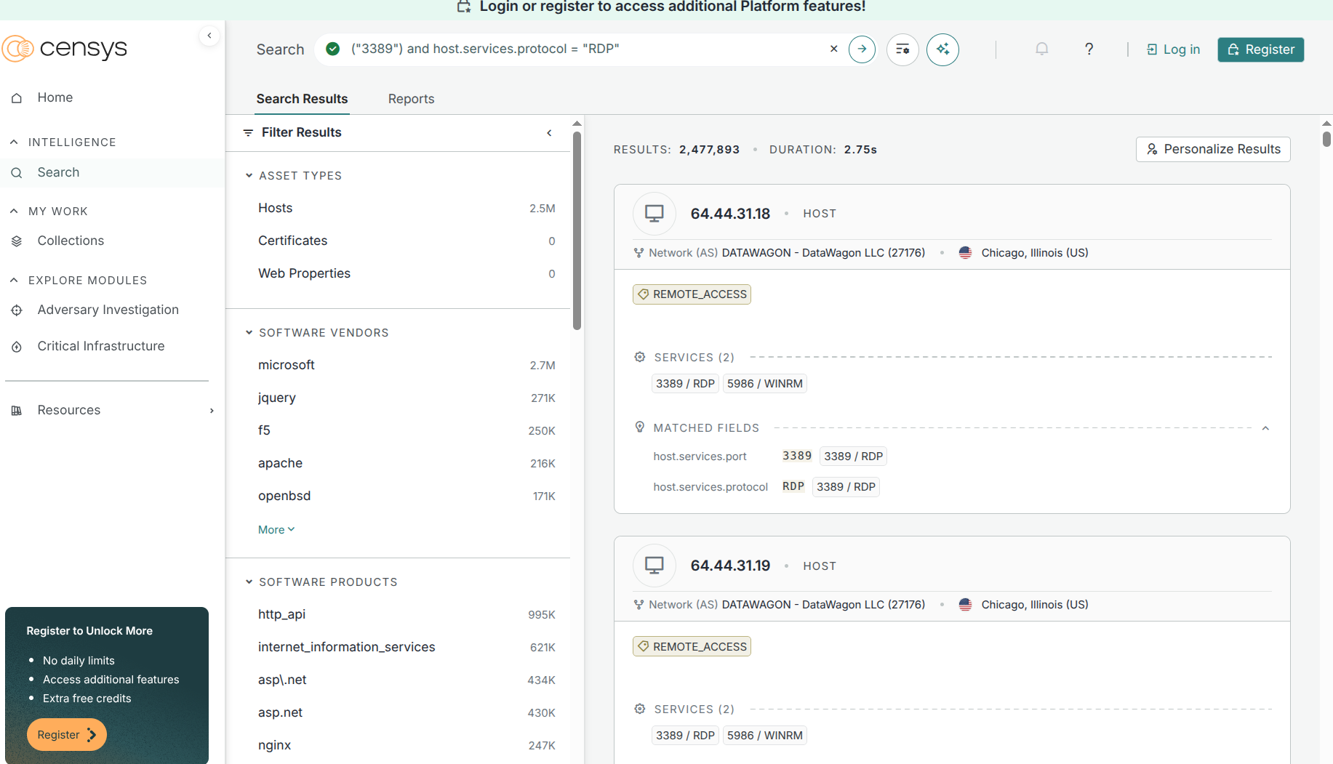
Figure 2: Censys search result interface
When diving into a matched host, this tool gives us more details such as Network and Routing data, Total Services indicates number of detected services on that host and details about each service. This information provides us with an initial investigative step to audit our system.
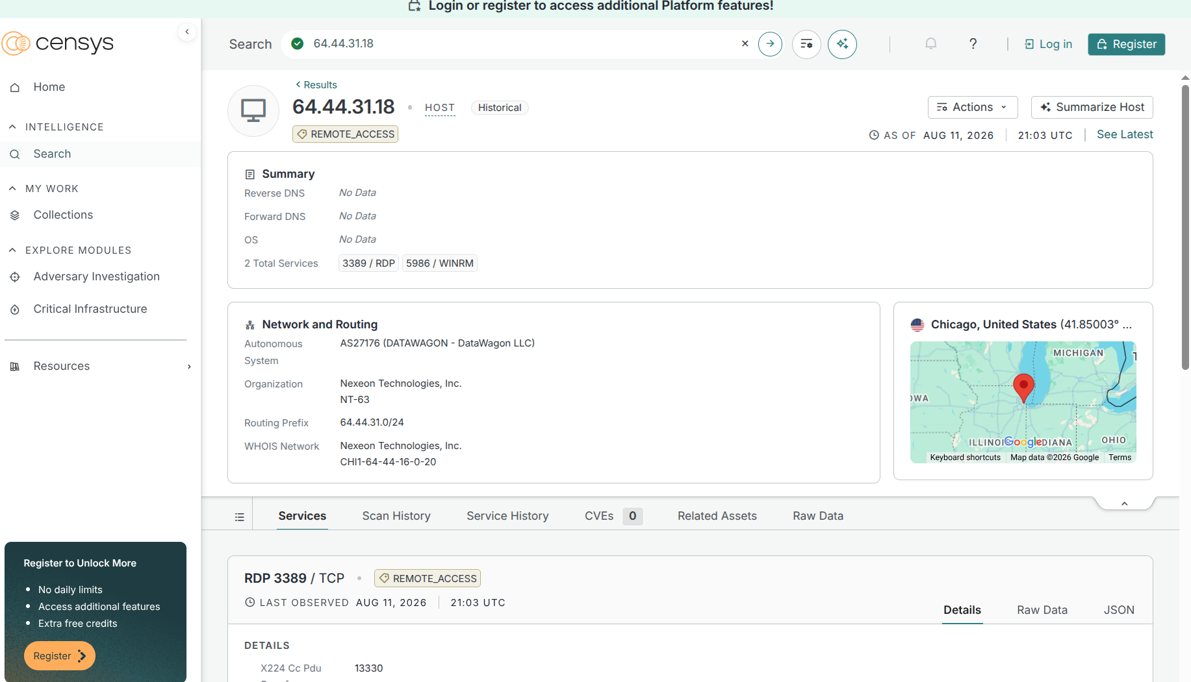
Figure 3: Details about a host

Protect your RDP:
- Disable when not in use.
- Enable MFA in RDP: https://learn.microsoft.com/vi-vn/windows-server/remote/remote-desktop-services/rds-plan-mfa
- Restrict access on firewall
- Better passwords
- Change default account

DAY 16: Create Alerts and Dashboards in Kibana (Part 2)

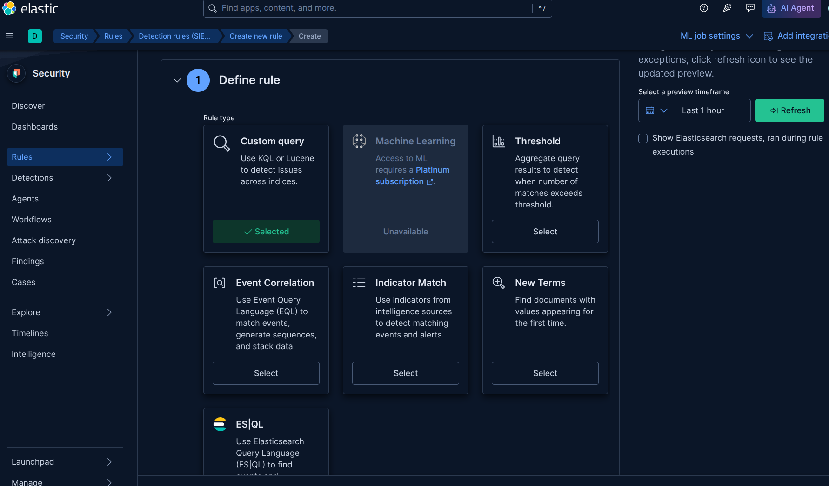
Figure 1: Types of security rules on Kibana
Today, I will use a threshold rule to detect brute-force attacks when the number of failed login attempts exceeds the threshold set by admin. The difference between the 2 types of rules is:

1. Custom Query — Create an alert for each document that matches condition
- Query language: Use KQL or Lucence to write the search queries.
- Mechanism: Each document (event/log) that matches query -> generate a separate alert.
- Example: A query searches for event.action: "login_failed" →
If there are 50 failed login events throughout the scanning process, that rule will generate separate 50 alerts, with each alert corresponding to one matching document.
- Suitable when: You want to know the details per suspicious event rather than count the number of occurrences.

2. Threshold — Create an alert when the number of matching events exceed threshold
- It also uses a query to filter data. Additionally, the next step executes a count of all matching documents (aggregate).
- Mechanism: The rule generates a single alert when the total of matching documents exceeds a threshold that you set. The events are usually counted within a time period and/or grouped by a particular field.
- Example: Use the same query, event.action: "login_failed", but set a specific threshold, example is 5. If the same user has 5 or more failed login attempts within 5 minutes → the rule generate a single alert, instead of separate 5 alerts.
- Suitable when: You want to detect anomaly behaviours about frequency/quantity (brute force, DDoS, port scanning,...) without triggering false positive alerts for each event.

Comparison Overview
Criterias | Custom query | Threshold
The number of alerts generated | 1 matching alert / document | 1 alert / khi tổng số match vượt ngưỡng
Counts quantity? | No | Yes (aggregate + compare to threshold)
Group by field | Not Supported | Yes (e.g., group by user.name, source.ip)
Typical use case | Detect an individual suspicious event. For example: execute a danger command. | Detect anomalous repetitive behaviour (e.g., brute force login)
Noise level | Prone to triggering excessive alerts when the event occurs frequently. | Consolidate into fewer alerts to reduce noises.
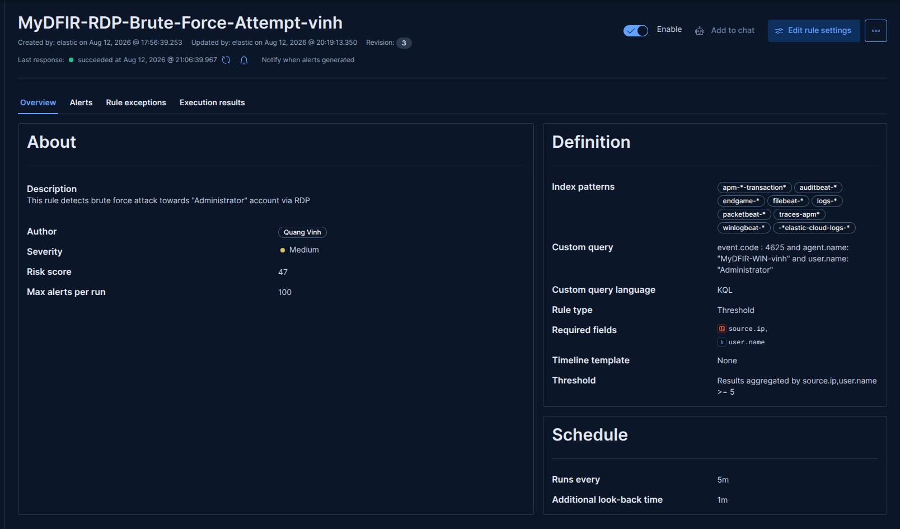
Figure 2: Threshold rule detect RDP Attack
The figure 2 shows a summary of the RDP brute force rule we have just configured. In the About and Definition panels, we can see the core configuration that we set, such as severity, max alerts per run, and the custom query. The custom query section is important because it defines which specific events the rule will search for.
In this case, we look for Windows events with code 4625, which indicates a failed login attempt. I also specify host name through agent.name field and target username is “Administrator”, which is the account the attackers are attempting to access.
The threshold specifies how many matching documents are required to trigger an alert. As shown in figure 2, this rule will trigger an alert when it finds more than 5 documents that match the custom query, and group by source.ip and user.name fields.
Because I want to verify that this rule is working correctly, I initially set the threshold to a relatively small value of five. Once I confirm that the rule detects the attack correctly, I will increase the threshold to a more appropriate value.

In the Schedule section, we can see two parameters: “Run every” and “Additional look-back time”. Both parameters affect the time range that the rule uses to search for events.
- Run every: this specifies the interval between rule executions. For example, in figure 2 I set it to 5 minutes, which means this rule will be executed every five minutes.
- Additional look-back time: this specifies an additional period that the rule looks back into the past when searching for events. This can help compensate for delays caused by network latency, data ingestion lag or delayed triggered rule,…
For example: if Run every is set to 5 minutes and look-back time is set to 1 minute, the rule will run every 5 minutes and search an additional one minute into the past beyond its normal time window.
Additionally, the Alerts tab displays alerts triggered by the rule and offers a visual bar chart for attack statistics. This tab is presented in Figure 3 below:
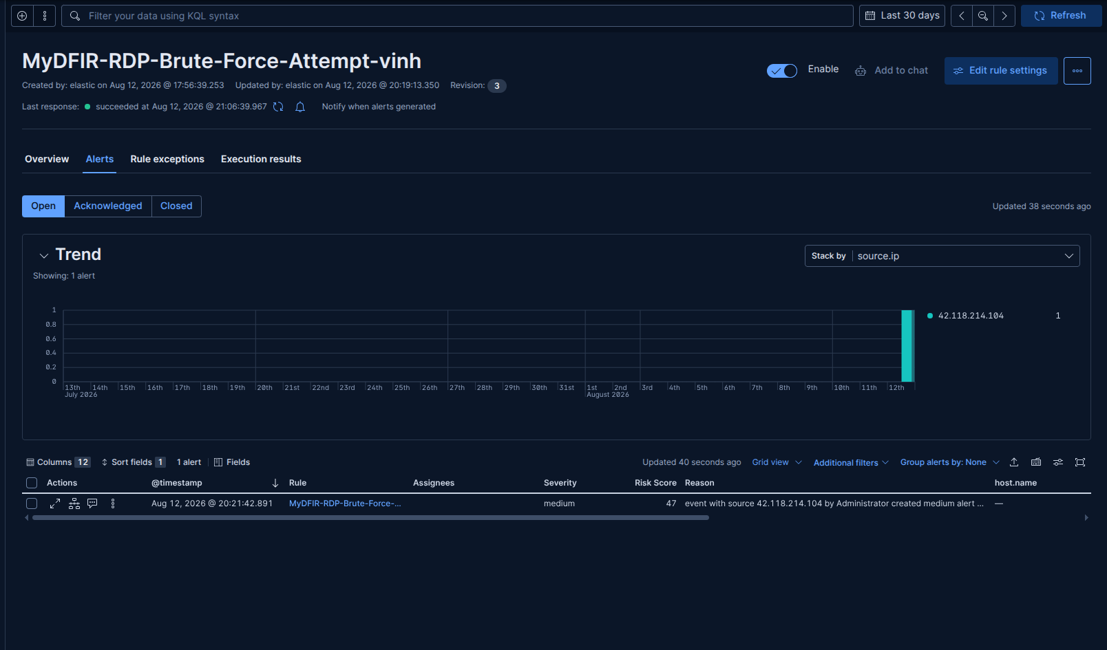
Figure 3: Alert RDP brute force attack

REFERENCE
[1] https://www.knowi.com/blog/what-is-elastic-search/ or https://viblo.asia/p/elasticsearch-series-p3-documents-types-va-indices-trong-elasticsearch-3P0lPYXG5ox

[2] How does inverted index work?
https://codingexplained.com/coding/elasticsearch/understanding-the-inverted-index-in-elasticsearch
[3] https://datadope.io/en/beats-a-elastic-agent/
[4] https://www.elastic.co/docs/manage-data/ingest/transform-enrich/ingest-pipelines#:~:text=For%20example%2C%20you%20can%20use%20pipelines%20to,Ingest%20Pipelines%20feature%20or%20the%20ingest%20APIs.
[5] https://www.sans.org/newsletters/ouch/power-passphrase

